C-FernTM Investigations:

Chemical Attraction
C-Fern Sperm Chemotaxis Kit
Instructor Version

Introduction
In this manual, a vertical bar to the left of text indicates material included in the Instructor’s Version only. The other material makes up the Student Instructions. Remember to refer to the Culture Instructions for C-Fern Investigations for detailed instructions for all procedures. To help students with specific procedures, you may photocopy appropriate sections of the Culture Instructions for use within your own class.

Note: This is an accessory kit that can be used independently or with any other C-Fern Kit. Instructions and materials for generating the mature gametophyte cultures that are required to use this kit can be found in any other kit and in the C-Fern Manual.

Observation and manipulation of organisms or cells that show rapid and distinct chemotactic behaviors can be a dramatic and compelling laboratory exercise for students. Although chemotaxis is a widespread phenomenon that clearly demonstrates the ability of cells to sense as well as respond to their chemical environment, it is typically allotted only brief, if any, coverage in the biological curriculum. Rarely are laboratory experiences provided. A principal reason for this may be the need for high power microscopy or other specialized equipment as well as living cultures of a responsive organism. This C-Fern Sperm Chemotaxis Kit overcomes these obstacles by providing opportunities for students to not only observe but to also manipulate and measure sperm chemotactic behavior using simple techniques, low power microscopy and easily grown cultures. All manipulations and observations can be made using a stereomicroscope at 12X or higher equipped with transmitted (bottom) or oblique illumination. This is an accessory Kit that can be used independently or in conjunction with any other C-Fern Kit. The exercise is suited for both high school and undergraduate students and can be easily adapted for more limited or extended investigations.

Background
Chemotaxis is a widespread biological phenomenon that occurs in essentially every form of life, from single cells to multicellular organisms. Chemotaxis involves the ability by specific cell types to recognize the presence of a chemical gradient and to respond either positively or negatively to that gradient. Familiar examples of chemotaxis are the movement of bacteria toward or away from a particular chemical (e.g., foodsource) and the nearly universal ability for single-celled gametes to locate one another in order to accomplish fertilization. Chemotaxis is even considered to play a key role in the metastatic behavior of certain types of malignant cancer cells as they spread to different tissues in the body.
Chemotaxis can be easily demonstrated in cultures of C-Fern gametophytes by observing the natural sequence of fertilization events that occur upon adding water to cultures. Mature (12+ day-old) populations of C-Fern gametophytes contain two distinct sexual types, small thumb-shaped males and larger heart-shaped hermaphrodites. While the males contain only antheridia (male sex organs), hermaphrodites contain both antheridia and archegonia (female sex organs). Antheridia are composed of a few outer cells that enclose 16 sperm at maturity. Archegonia consist of a short neck that protrudes from the surface of the gametophyte directly behind the actively growing meristem region located in the notch of the heart. An egg is located at the base of each archegonial neck. By adding water to a mature culture, it is possible to observe the release of thousands of swimming sperm (mostly from males). The sperm are positively attracted to receptive archegonia. How do sperm know where the archegonia (and eggs) are? Sperm are attracted to chemical substances (positive chemotaxis) that are contained in a small drop of liquid that is discharged from the necks of receptive archegonia. One sperm eventually succeeds in fertilizing each egg.
In addition to observing these natural behaviors in culture, it is also possible to artificially manipulate sperm so that experiments combining aspects of both chemistry and reproductive biology can be conducted. In this exercise you will use a simple technique to obtain a suspension of sperm and then test the ability of the sperm to respond to several test substances.

Learning Objectives
- Observe natural and artificially manipulated chemotaxis in C-Fern sperm
- Learn techniques of qualitatively interpreting experimental results.
- Gain experience with viewing and manipulating objects under the microscope
- Learn about the structural differences between chemical isomers and how the differences can effect their biological activity

Materials
Materials included in the Kit:
- 6 Concavity slides
- 6 Dissecting needles
- Sterile pipette
- Toothpicks and toothpick holder (foam block)
- 3 Petri dishes (for support of slides)
- Razor blades
- Marking pen
- 6 Test solutions and sperm release buffer:
VIAL LABEL | CONTENTS¹
SRB | sperm release buffer
#1 | 20 mM succinic acid
#2 | 20 mM L-malic acid
#3 | 20 mM D-malic acid
#4 | 20 mM fumaric acid
#5 | 20 mM maleic acid
¹ All solutions are prepared in SRB (5 mM Tris, pH 8 + 1 mM CaCl₂)

Materials needed but not supplied:
- 12-18 DFS cultures of C-Fern gametophytes
- stereomicroscopes with appropriate lighting (transmitted and/or oblique illumination)

Procedures and Observations
Your instructor will provide you with 12-18 day-old cultures of C-Fern gametophytes. These cultures should be maintained under the standard culture conditions until just before use. Do not remove cultures from under the lights or from the Culture Domes until steps 1-3 have been completed!
When cultures are removed from their culture location (e.g., Culture Dome) or otherwise subjected to a change in temperature, release of sperm can occur even in the absence of water. Therefore, in order to maximize sperm yield for the experiments, keep all cultures in stable conditions until just before use.

1. Using the razor blade, carefully sharpen six of the wooden toothpicks provided (for each group, up to six groups) so that one of the ends has a very fine point. Use the razor blade carefully! Cut away from yourself and watch your fingers. When you are finished sharpening, do not touch the sharpened end with your fingers. Carefully lay the toothpicks down on a clean surface. Replace the razor blade in the container designated by your teacher.

This step can be done beforehand to avoid the use of razor blades during class. If doing so, be sure to store the sharpened toothpicks, sharp end down, in a clean vial or envelope. It is important that the sharpened ends do not come into contact with foreign surfaces or fingers.

2. Use the pen to make from 1 to 5 small dots along the side of the toothpicks near the unsharpened ends, so that each toothpick has a unique marking (i.e.,1,2,3,4,5) and one is kept unmarked. Take the toothpick with one dot and dip the sharpened end of it into the vial containing test solution #1. Place it, sharp end up, in the toothpick holder (foam block). Repeat with the remaining 4 test solutions, leaving the final unmarked toothpick dry.

Q1. Which of the toothpicks will serve as a control? Why is the one you chose appropriate to be used as the control?
The toothpick that was not dipped in a solution can serve as a control because it has none of the test chemicals on it. An alternate control could be a toothpick that was dipped in the Sperm Release Buffer only, and not into a test solution.

3. Obtain a concavity slide and, using the pipette, place one drop of the Sperm Release Buffer (SRB) in the central depression.

4. Now obtain a petri dish containing mature C-Fern gametophytes. Open the dish and observe it under a stereomicroscope using transmitted (bottom) illumination. Note the two types of gametophytes that are present, larger heart-shaped hermaphrodites and smaller thumb-shaped males that have many bumps on them (Fig. 1). Take the dissecting needle and carefully pick up males only and transfer them to the drop in the concavity slide. Be careful to not damage or wound the gametophytes during transfer. If one is wounded, discard it. Transfer a total of 7 – 10 male gametophytes to the drop. It is not necessary to submerge them completely, only to place them within the drop of buffer.

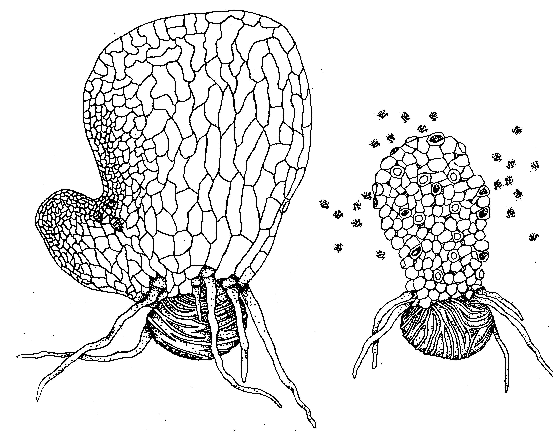It may be useful to use Fig. 1 to discuss the differences between males and hermaphrodites prior to students’ obtaining the culture dishes. This would allow them to make the transfers more rapidly to avoid loss of sperm through premature release.

Figure 1. Mature (12-day-old) hermaphrodite (left) and male (right) C-Fern gametophytes.

Q2. Why are only males transferred to the drop of buffer?
Transfer of hermaphrodites would reduce the response to substances being tested on the toothpicks since many sperm would be attracted to receptive archegonia by the natural chemoattractant that is released from the archegonial necks.

5. Place the slide on either the lid or bottom of an empty petri dish, edges up, and observe it under the stereoscope under low magnification (12X or higher). The use of the petri dish will keep the slide and sperm suspension cooler and provide a clearer view. In a few minutes, usually less than five, sperm should begin to be released from antheridia. Adjust the illumination on the stereoscope to provide the best contrast for viewing the sperm. Your teacher will assist you.

Adequate observation of the sperm suspension is critical for the success of this exercise. Although only low magnification is needed to visualize swimming sperm, microscopes vary widely in the type of illumination available and this can be a critical factor. The following suggestions are made to assist you in lighting adjustments, but the best approach is to experiment with your particular equipment before the laboratory is initiated.
- top illumination will usually produce too much glare in the drop of liquid and consequently restrict observations
- bottom illumination works for good quality optics and where the intensity of the light can be adequately adjusted, but many student microscopes are not adequate in these regards.
- avoid excessively bright illumination
- oblique illumination, from the side, often can produce very acceptable results
- If the microscopes are equipped with a mirror below the stage, it can be adjusted to give a ‘pseudo-darkfield’ type of illumination where the background is dark and the sperm appear as light-reflecting bodies.
- it is also helpful to turn the microscope light off while waiting for sperm release in order to reduce the heat buildup from the light

6. After a large number of sperm are released (about 3-5 min), begin testing the response to the test solutions as follows:
- Using 12-20X magnification, carefully focus on the TOP surface of the drop of sperm suspension, in an area free of male gametophytes.
- Take a test toothpick and, while looking through the microscope, gently and briefly touch the sharpened end of the toothpick to the surface of the drop. Do not stick the toothpick fully into the drop – only touch the surface briefly. See Figure 2a.
- Observe what happens, if anything, during the next minute and record your observations in Table 1.
- After you have made your observations, repeat the procedure with the remaining toothpicks. If necessary, use the dissecting needle to stir the sperm suspension and re-distribute sperm after each of the tests. This is typically needed only after a strong chemotactic response is observed.

METHODS HINT: If you wish to repeat any of the tests, simply re-use the toothpicks. Stir the suspension as needed to distribute the sperm randomly. It is also possible to test two substances simultaneously by holding two toothpicks together (side-by-side) so that their sharpened tips line up. Then, while observing the sperm suspension, briefly touch the tips to the drop of suspension as before (see Fig. 2b). Observe the two points of contact and compare the responses directly.

- OPTION: Wound one of the gametophytes in the sperm suspension by puncturing it with the dissecting needle. Observe what happens. Another option is to crush a gametophyte from the original culture dish with a sharpened toothpick and test this toothpick as described above. Record your results.
- OPTION: Your teacher may provide you with toothpicks that contain the natural chemoattractant from the exudate from archegonia. Alternatively, you may prepare these in laboratory following instructions from your teacher. Test these as above and record your results.

Figure 2a. Proper technique is important. Gently and briefly touch the end of the toothpick to the surface of the sperm suspension. Note: The size of the drop of suspension is exaggerated to show detail.
Figure 2b. Simultaneous testing with two toothpicks held side-by-side.

Q3. You may have observed a very weak response by the sperm to the control toothpick. How could this be explained and does it invalidate the experiment?
Typically, a very slight response can be observed even for the control toothpick. Breaking the surface tension of the suspension with the toothpick and/or creating a slight difference in electrical charge on the touched surface may cause this. Since there is also a very clear difference between this ‘background’ response and the positive chemoattractants, it does not invalidate the experiment. In fact, interpretations of many types of experiments must typically factor in background level responses.

Q4. Which of the test chemicals caused the strongest response?
L-malate shows a very strong and long-lasting response while its stereoisomer D-malate shows a much weaker response. If D- and L-malate are tested simultaneously (see Methods Hint), a swarm will form initially for both, but within 1 minute the D-malate swarm will move to the L-malate swarm! Maleic acid also shows a strong response, while its cis/trans isomer fumaric acid shows a weak response. Succinic acid shows a very weak response.

Q5. Examine the chemical structures provided by your teacher. Can you relate the biological response differences you observed (chemotaxis) to any chemical structural differences between the test substances?
All of the test substances are four-carbon acids. Succinic acid lacks the hydroxyl group that is present on the others. Since it gives a weak response, the hydroxyl group appears important for recognition. The differences between L- and D-malate and maleic and fumaric acid suggest that the position of the hydroxyl group is also significant. Presumably, membrane surface receptor sites on the sperm have different affinities for the different chemicals, and this is based on their structure. However, membrane receptors associated with the C-Fern chemotactic response have not yet been isolated or described, so their existence is only hypothetical.

Q6. Can you relate the positive chemotactic activity of some of the chemicals to the natural attraction of sperm to substances in the exudate from the necks of receptive archegonia?
L-malic acid is a common Krebs cycle intermediate and is likely a significant component of the discharge from receptive archegonia. This discharge, which may also contain other unknown chemoattractants, allows sperm to locate receptive archegonia containing eggs. Succinic acid and fumaric acid are also Krebs cycle intermediates but, presumably, because of their structures they are ineffective as attractants. Although maleic acid is also a strong attractant, it is a synthetic compound and is not known to be common naturally.

Q7. If you tested the chemoattractant effect of wounded gametophytes (step 6e.), can you relate your observations to the natural attractant discussed in Q6?
Material from wounded cells acts as a strong chemoattractant, presumably because of the presence of L-malate and/or other cellular substances that are strong attractants. An interesting extension of this would be to have students test sap from wounds of other ferns and non-fern plants to see if they showed a positive response.

Option for natural chemoattractant: In addition to the test substances provided in this kit, it is also possible to coat tips of sharpened toothpicks with the natural substance released by archegonia. This can be done prior to class or integrated with the above exercise by the following procedure –
Place 12+ day-old gametophyte cultures in a refrigerator or other cool area for 15 min., then return to room temperature for one half hour. This treatment will cause the receptive archegonia to exude a small drop of viscous liquid from the necks. Frequently, the condensation caused by the cold treatment joins with the exudate to form a rather large drop in the area of the archegonia. This can be seen quite clearly with a stereomicroscope. The gametophyte area immediately behind the notch meristem should be examined. By taking a sharpened toothpick and touching it to the drop in the region of the archegonia on 7 – 10 gametophytes, enough can be collected to incorporate into the experiment. Note: In culture, the archegonia are located on one of the two sides (up or down) of the gametophyte. Therefore, it may be necessary to turn some gametophytes over in order to collect enough exudate. The cultures used for the archegonial exudate should not be used for harvesting male gametophytes, since the antheridia will also release sperm prematurely because of the cold temperature treatment.

Table 1. Chemotactic response of C-Fern sperm to test substances.
Test Substance | Swarming Response¹
Test Substance | Intensity (low, medium, high) | Duration (short, medium, long) | Comments
¹A quantitative measure can be approximated by assigning values (0,1,2,3…) or symbols (-,+, ++,+++…) to the responses. This allows easier comparison with data sets generated by other students.

The following representations of the chemical structures can be used in a variety of ways to integrate students’ understanding of chemistry and biology. For instance, a chart showing structures of compounds 1-3 or 1-5 could be combined with the following questions:
1. Which compound is most active as a chemoattractant?
2. What structural feature appears to be critical for activity?

Figure 3. Chemical Structures of the Test Compounds. (A. succinic acid B. L-malic acid C. D-malic acid D. fumaric acid E. maleic acid.)

Figure 3. Chemical Structures of the Test Compounds.

D

A

B

C

E

